Will AI replace most of the workers in financial field?

Name: Qi Zhao

University : George Washington University

Department: Computer Science

Author Note

This paper is prepared for EAP6110, Section 26, taught by Professor Stanchevici.

Will AI replace most of the workers in financial field?

**Introduction**

On March 15, 2016, as the Alphago beat Lee Sedol 4-1 to win the five-game Go match (Hun, March 15, 2016), a kind of chess which is regarded as the last line of defense for privileging human over machines or robots, the concept of artificial intelligence, AI for short, has drawn a great deal of attention from various fields. Since then, more and more people are considering the possibility of utilizing AI to solve the problems that they met in life or work. Especially for a company’s management, who have always been puzzled about how to manage workers, they might be more willing to consider the possibilities that employing a submissive AI to work for them. In fact, many high-tech companies like Google, Microsoft, Amazon, and Facebook have applied AI technologies in their products to improve the performance of some specific applications. Besides that, many traditional financial companies like BlackRock have applied AI in their systems to help the management make better decisions (Lin, 2016, p.162). And this trend is spreading across the entire financial field. This research paper considers whether the AI technology may take over most of the job positions in financial field in the future by responding to the following questions:

1. How widely and deeply has AI been applied in financial field?
2. Why is AI a better choice than human workers for financial company?
3. What kinds of jobs would probably be taken over by AI?

Comparing to human workers, AI is more effective and cheaper for routine jobs which constitute a large part of the job positions in financial companies. It seems inevitable and grim that AI may eventually take over most of human workers’ jobs in the financial companies in the future.

**How widely and deeply has AI been applied in financial field?**

AI has been applied in multiple dimensions of the financial industry: from trading to research to wealth management. Since about 1990s, people got start to use AI technologies to predict stock price. According to a poll undertaken by KD Nuggets in 2010 (Figure 1), there was an increasing trend in utilizing data mining technique, a kind of AI technology that is often used to design quantitative trading tools, in investment until 2008. Nowadays, almost every significant financial institution utilizes AI technologies to build some models to control risk and manage their money. For example, BlackRock, the world’s largest asset management company, operates a proprietary artificial intelligence program, called Aladdin, to manage risk on behalf of its clients (Lin, 2016, p.162). As Lin (2016) pointed out, during the financial crisis of 2008, the US federal government turned to BlackRock and Aladdin for guidance on critical decisions, and it shows how powerful the AI technologies could be (p.162). According to Hilovska and Koncz (2012), there are six typical AI technologies being applied in financial field so far: Data Mining, Expert Systems, Genetic Algorithms, Fuzzy Systems, Artificial Neural Networks, and Agent-based Computational Economics. Artificial intelligence is not a new concept in financial field, and its application is being developed rapidly and profoundly.

The application of AI technologies has largely changed the organization of the modern finance companies. In 2000, Goldman Sachs employed 600 equity traders for its New York trading desk. But today, it just employs two traders with the machine doing the rest of the work (Maney, 2017, p.47). According to Lin (2016), JPMorgan Chase probably employs more software developers than Google and more technologists than Microsoft in recent years (p.161). This phenomenon indicates the trend of modern financial companies are becoming high-tech organizations.

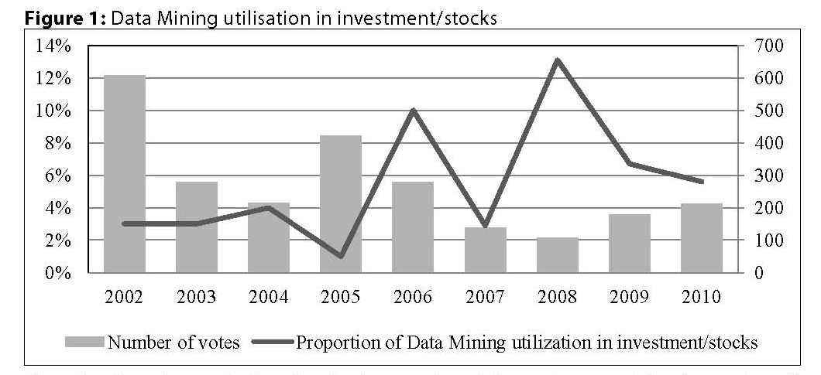

Note: Number of Votes depicts the absolute number of data miners participating at the poll and the percentages are relative to the number of votes

Source: KDnuggets Pool, 2010[Online].[s.a.].[Cit. 2010-02-01]. Available at: <http://www.kdnuggets.com/polls/2010/analytics-data-mining-industries-application.html>

**Why AI is a better choice than human workers for financial company?**

For most of the tasks in a financial company, AI performs faster, more accurately, and more impartial. Work in a financial company that now takes hours, days or weeks of human labor may well be completed in minutes or seconds by AI. According to Barry Libert and Megan Beck (2017), *The processing power of four smart consultants with excel spreadsheets is minuscule in comparison to a single smart computer using AI running for an hour, based on continuous, non-stop machine learning (p.3, italics originated)*. Because of the massive computing power and extraordinary precision of supercomputers on which AI runs, Artificial Intelligence will be able to collect and analyze huge quantities of data--books, tweets, news reports, financial data, earning numbers, and anything that is related to its tasks--and yield accurate and reliable results. This means decision making with AI support can partly eliminate the bounded rationality of decision maker and achieve better decisions with more relevant data and information (Hilovska and Koncz, 2012, p.62). Besides, AI does not suffer from the irrational “animal spirits” that move humans. As a management assistant, AI can appropriately recognize and reward performance of the workforce without considering their gender or race. AI can also help make resource allocation decisions based on the evaluation of input and output other than personal preference of the decision maker. Obviously, comparing to human workers, who are limited by their physical strength, the brains’ processing power, and emotions, AI is more suitable for general tasks in financial field.

In addition, the potential huge cost reduction also attracts financial companies to replace human workers with AI. As Maney (2017) showed, the average compensation for staff in sales, trading, and research at the 12 largest investment banks is $500,000 (p.47). If these banks replace most of their workers with AI, there will be an astronomical number of cost being reduced. Similar financial companies could apply similar AI technologies. Even though the cost of research and development of an AI technology seems very high for a single company today, it remains a fraction of the total potential reduced cost of all financial companies that apply that technology in the future. As a replacement to the human workers, AI is cheaper, faster, more accurately, and more impartial.

**What kind of jobs would probably be taken over by AI?**

The work that can be broken down into a series of discrete tasks, which are relatively predictable and tend to be repeated over and over again, would most probably be occupied by AI (Martin, 2013, p.37). For example, the working process of bank tellers could be divided into four stages--receiving, translating, transmitting and feedback. AI can totally handle these simple tasks. In fact, the automatic machines of self-service have significantly reduced the number of bank tellers. In the future, AI will replace the bank tellers and even eliminate this kind of job.

Furthermore, some job positions that seem creative like the trader, the fund manager, and the financial advisor, may well be taken over by AI. A large part of what is paid for with managers’ and advisors’ service is data analysis and presentation. These workers are very good at gathering, cleaning, processing, and interpreting data from disparate sources, but AI is even better. The AI technology of data mining can be used to efficiently collect and analyze data, while another AI technology of expert systems can be used to emulate the reasoning process of a human expert and make high-quality decisions (Hilovska and Koncz, 2012, p.65). Consequently, only people who engage in the truly creative occupations such as the designer of AI algorithms, creator of trading strategy, an decision maker will not be replaced by AI.

**Conclusion**

Due to the higher performance and lower cost, AI will eventually replace most of the human workers in financial field. In fact, AI technology has been applied in financial field for a few decades, and now it is a dispensable part of modern finance. AI exceeds human workers in many ways such as processing speed, amount of memory, precision, impartiality, and endurance. In the future, most general job positions like traders, fund managers, and financial advisors would be taken over by AI, and easy jobs like bank tellers will even be eliminated. Only the truly creative jobs such as designers of AI technologies and decision makers will be definitely remained. That means a large amount of people will lose their jobs. What should they do next? That is a fairly serious issue deserves to be considered by government and every common people.

**References**

Barry, L. & Megan, B. (2017, July 24). AI may soon replace even the most elite consultants. [*Harvard Business Review Digital Articles*](javascript:__doLinkPostBack('','mdb~~bth%7C%7Cjdb~~bthjnh%7C%7Css~~JN%20%22Harvard%20Business%20Review%20Digital%20Articles%22%7C%7Csl~~jh','');)*.* Retrieved from http://web.b.ebscohost.com.proxygw.wrlc.org/ehost/pdfviewer/pdfviewer?vid=5&sid=ad748c20-4536-438b-8d69-409595f520d1%40sessionmgr102

Hilovska, K. & Koncz, P. (2012). Application of artificial intelligence and data mining techniques to financial markets. *Economic Studies & Analyses / Acta VSFS*, 6(1), 62-76. Retrieved from <http://web.a.ebscohost.com.proxygw.wrlc.org/ehost/pdfviewer/pdfviewer?vid=14&sid=789b9dbc-699a-4e9d-9143-1eb0551d5175%40sessionmgr4008>

### Hun, C. S. (March 16, 2016). [Google’s Computer Program Beats Lee Se-dol in Go Tournament](https://www.nytimes.com/2016/03/16/world/asia/korea-alphago-vs-lee-sedol-go.html) *The New York Times*. Retrieved from https://www.nytimes.com/2016/03/16/world/asia/korea-alphago-vs-lee-sedol-go.html

KDnuggets Pool, 2010[Online].[s.a.].[Cit. 2010-02-01]. Available at: <http://www.kdnuggets.com/polls/2010/analytics-data-mining-industries-application.html>

Lin, T. C. W. (2016). Compliance, technology, and modern finance. *[Brooklyn Journal of Corporate, Financial & Commercial Law](javascript:__doLinkPostBack('','mdb~~bth%7C%7Cjdb~~bthjnh%7C%7Css~~JN%20%22Brooklyn%20Journal%20of%20Corporate%2C%20Financial%20%26%20Commercial%20Law%22%7C%7Csl~~jh','');" \o "Search for Brooklyn Journal of Corporate, Financial & Commercial Law)*, 11(1), 159-182. Retrieved from <http://web.a.ebscohost.com.proxygw.wrlc.org/ehost/pdfviewer/pdfviewer?vid=7&sid=789b9dbc-699a-4e9d-9143-1eb0551d5175%40sessionmgr4008>

Maney, K. (2017, October 3). Goldman sacked. *Newsweek Globe*, 168(9), 46-47. Retrieved from http://web.a.ebscohost.com.proxygw.wrlc.org/ehost/pdfviewer/pdfviewer?vid=10&sid=789b9dbc-699a-4e9d-9143-1eb0551d5175%40sessionmgr4008

Martin, F. (2013). Viewpoint: Could artificial intelligence create an unemployment crisis? [*Communications of the ACM*](javascript:__doLinkPostBack('','mdb~~bth%7C%7Cjdb~~bthjnh%7C%7Css~~JN%20%22Communications%20of%20the%20ACM%22%7C%7Csl~~jh','');), 56(7), 37-39. DOI: 10.1145/2483852.2483865